**Project Initialization and Planning Phase**

|  |  |
| --- | --- |
| Date | 03 July 2024 |
| Team ID | 740064 |
| Project Name | Trip Based Modeling of Fuel Consumption in Modern Fleet Vehicles Using Machine learning |
| Maximum Marks | 3 Marks |

**Define Problem Statements (Customer Problem Statement Template):**

The project's goal is to create a prediction model that can reliably calculate fuel consumption per trip based on factors including driving style, vehicle attributes, and road conditions. With the aid of machine learning algorithms, the model will pinpoint the major variables affecting fuel efficiency and produce accurate forecasts. By doing this, driving habits will be improved, resulting in economical fuel consumption and less environmental effect. The finished product will be an invaluable resource for fleet managers, drivers, and other transportation specialists.

It's critical to forecast trip-based fuel usage to maintain both environmental sustainability and cost-effectiveness. Route conditions, driving behavior, and vehicle specs all affect this usage. Conventional techniques for calculating fuel use are frequently inaccurate and time-consuming; however, machine learning provides effective substitutes by examining data to find trends and generate precise forecasts. methods such as decision trees and regression can optimize driving practices, ensuring fuel efficiency and reducing costs in transportation

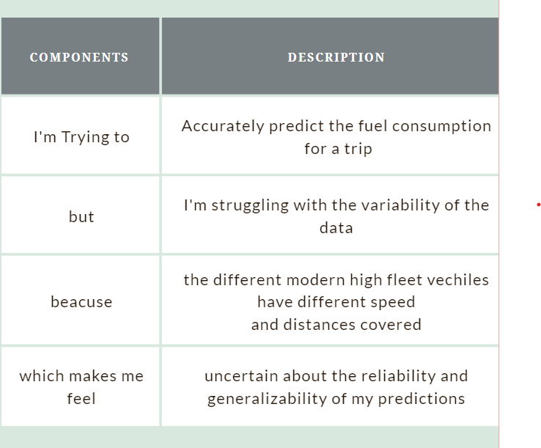



Reference: https://miro.com/templates/customer-problem-statement/

**Example: Predicting the fuel consumption**

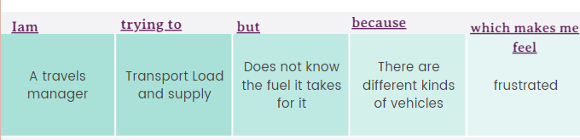

|  |  |  |  |  |  |
| --- | --- | --- | --- | --- | --- |
| **Problem**  **Statement**  **(PS)** | **I am**  **(Customer)** | **I’m trying to** | **But** | **Because** | **Which makes me feel** |
| PS-1 | A travels manager | Transport Load and supply | Does not know the fuel it takes for a trip | There are different kinds of vehicles | frustrated |
| PS-2 | Vehicle driver | Go on a trip with a group of people | The fuel gets completed | With speed varies How much is needed is not known | worried |